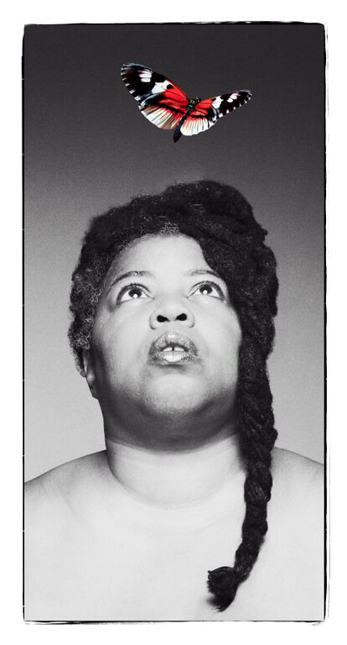

By Cheryl Martin
Co-commissioned by hÅb for Domestic II and The Albany

Join us for Alaska at The Albany, Deptford, 7 or 8:30 pm
http://www.thealbany.org.uk/event_detail/1652/Theatre/Alaska-
Contact Jayne Compton for tickets – jayne@switchflicker.co.uk

“Exceptionally good… The poet delivers her material with such energy, charm, emotion and honesty… Food for the soul"
-- The British Theatre Guide
ALASKA
“ I was really impressed… mature and complex work that was being rigorously thought and talked about”
-- Richard Gregory, Quarantine

“In order to be beautiful, you need to be brave”
-- The British Theatre Guide

Alaska is a funny, magical trip to the moon, with singing and dancing thrown in: one woman’s extraordinary story of how she survived growing up with severe depression.
Alaska, the one-woman-show, is inspired by writer-performer Cheryl Martin’s poetry collection, longlisted for the 2015 Polari Prize.
“I called the show ALASKA after a line in a Lou Reed song, Caroline Says II, that goes ‘It’s so cold in Alaska.’ I chose that because most of the time my emotions seem numb, frozen. Then something happens and they wake up.”
A raw and powerful performance, with humour, heart and soul, with stunning vocals and beautiful imagery in the storytelling. With one in four of us estimated to experience mental health difficulties at sometime in our lives, this is a story that touches everyone, whether first-hand or through family and friends.
“It is a devastatingly beautiful show, … poetic narrative and heart achingly profound... absolutely pioneering …people should go”
– Chanje Kunda, performance poet and artist, Manchester Theatre Awards Nominee

Co-commissioned by hÅb for Domestic II and The Albany
Supported by Contact, STUN, Commonword, Arts Council England, PANDA and
Simon Lucas Bridge Supplies

Trailer: https://vimeo.com/144167182

‘Cheryl never compromises, she just tells it how it is. A beautiful performance. Brave, courageous, and very powerful. Would like to see more of her work ’
- Audience member

THE TEAM
Written and Performed by Cheryl Martin

Cheryl Martin was born in Washington, D.C., grew up in nearby Maryland, and went to university at Williams College in Williamstown, Massachusetts in the States and Emmanuel College, Cambridge in England. She loves Manchester, her adopted city.
Cheryl has won Manchester Evening News Theatre Awards as both writer [ Best Community Production, Heart and Soul, Oldham Coliseum and director Best Studio Production, Iron by Rona Munro, Working Girls/Contact, an Edinburgh Fringe First as co-director and producer of Traverse Theatre’s Breakfast Series The World Is Too Much, and this year a Lloyd’s Bank regional award for the immersive play she directed for Community Arts Northwest, Rule 35, and longlisted for the Polari Book Prize for her collection of poems, Alaska Crocus/Commonword, the inspiration for this play.
http://www.cherylmartin.co.uk/about/
Cheryl Martin is a unique voice in today’s theatre, both in her own performances and in the work she makes with others as a director. In both kinds of work, she examines experiences that most people are afraid to talk about, but approaches them with a humour, warmth, and raw honesty that draws audiences in and allows them to explore with her, fearlessly.
Whether directing a writer like Alan Bissett in unearthing Scotland’s uneasy colonial history, or performing in her one-person show, ALASKA, to unearth a personal history of hospitalisation and mental illness, she brings a lightness and wealth of imagery to create worlds audiences love to dwell in.
That relationship with the audience is always key, creating a bond, creating trust, carrying them with you into a world they may think they fear to enter. In many immersive shows created with refugees, she invites the audience to live, for a short time, what other people’s lives feel like. With the joy and the wonder and the beauty that entails, as well as the harsh edges.
Director: Darren Pritchard –- www.darrenpritcharddance.com
Darren has a track record working with poets at Contact, as a performer with Quarantine [SUSAN + DARREN, GRACE], and the innovative interactive visuals on his own piece, BODY OF LIGHT.

Dramaturg: Matt Fenton –- http://contactmcr.com/staff/executive/matt-fenton/
Matt has a long history at Nuffield Theatre, Lancaster of working with digital art and experimental form, as with his own work IN MAY [Sick Festival 2014].

